CONTINUOUS ASSESSMENT TEST - I
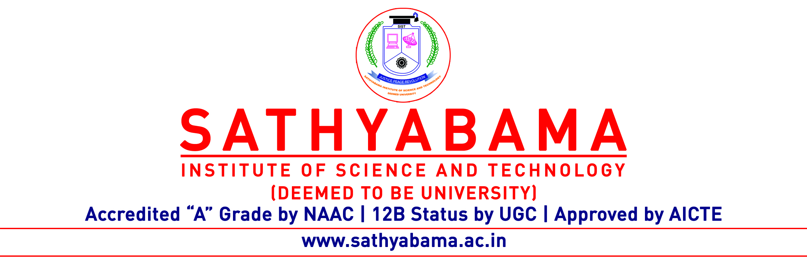
Program : CSE Max. Marks : 30
Course : B.E Time : 1 Hour
Course Code : SCS1301 Sem : V
Batch : 2018-2022 Date : 28.12.2020
Part-A Answer ALL the questions (5×2=10)

Q.No | Questions | CO (L)
 | Illustrate the use of fork and exec system calls. | CO1(L1)
 | Summarize the types of thread | CO1(L2)
 | Define the term Dispatch Latency. | CO2(L1)
 | What are conditions under which a deadlock situation may arise? | CO3(L2)
 | List out the different types of directory structure. | CO4(L2)
Part-B Answer ALL the questions (2×10=20)

Q.No | Questions | CO (L)
 | Explain various types of system calls with an example for each. | CO1(L2)
 | (OR)
 | Find the Average Waiting time and average Turnaround time for the below processes using SJF Scheduling | CO2(L5)
  Process | Burst Time
  P1 | 8
  P2 | 16
  P3 | 4
  P4 | 5

 | Examine the Reader Writer Problem with suitable example | CO3(L3)
 | (OR)
 | Explain the optimal page replacement algorithm with example | CO4(L5)

